

**Green University of Bangladesh**

**Department of Computer Science and Engineering (CSE)**

**Faculty of Sciences and Engineering**

**Semester: (Fall, Year:2022), B.Sc. in CSE (Day)**

**Course Title: Data communication Lab**

**Course Code: CSE 308 Section:203D1**

**Lab Project Name: University Networking Design Using Cisco Packet Tracer**

**Student Details**

|  |  |
| --- | --- |
| **Name** | **ID** |
| **Md. Abu Jafor** | **203002048** |

**Submission Date : 23/12/2022**

**Course Teacher’s Name : Ms. Sobhana Jahan**

**[For Teachers use only: Don’t Write Anything inside this box]**

|  |
| --- |
| **Lab Project Status**  **Marks: ………………………………… Signature: .....................**  **Comments: .............................................. Date: ..............................** |

Table of Contents

Chapter 1 Introduction 3

1.1 Introduction 3

1.2 Design Goals/Objective 3

Chapter 2 4

Implementation of the Project 4

2.1 Section (Choose the name of this section as appropriate with your project) **Error! Bookmark not defined.**

Chapter 3 Performance Evaluation 5

3.1 Configuring IP Addresses 5

3.2 Results and Discussions 12

Chapter 4 Conclusion 20

4.1 Introduction 20

4.1 Scope of Future Work 20

References 21

# Chapter 1 Introduction

## Introduction

Computer networks have a significant impact on the working of an organization. Universities

depend on the proper functioning and analysis of their networks for education, administration, communication, e-library, automation, etc. An efficient network is essential to facilitate the systematic and cost-efficient transfer of information in an organization in the form of messages, files, and resources. The project provides insights into various concepts such as topology design, IP address configuration, and how to send information in the form

of packets to the wireless networks of different areas of a university.

## Design Goals/Objective

The aim of this project is to design the topology of the university network using the software

Cisco Packet Tracer with the implementation of wireless networking systems. This university

network consists of the following devices:

1) Router (1941)

2) Switches (2960-24TT)

3) Email server

4) DNS server

5) WEB server (HTTP)

6) Wireless Device (Access Point)

7) PCs

8) Laptops

9) Smartphones

# Chapter 2

# Implementation of the Project

## Implementation & Flow Diagram :

● To design the wireless network of the university we initially started by placing the core devices into the frame.

● Firstly, we placed the main router at the center of the university outline, which was further connectedto the server switch using the gigabit Ethernet port with copper straight-through cable and sub routers (**City** campus router and **Permanent** router) using the serial port with serial DC E cable at the Lab,class room ,faculty area respectively.

● The server switch was further connected to the EMAIL, DNS, and WEB

servers respectively.

● Campus router was connected to the campus switch which was further

connected with wireless access points of the academic dome building and library.

● The wireless access points were then connected to computing devices (PCs,

laptops, and smart phones).

● Similarly, the hostel router was connected to the hostel switch which was further connected with the wireless access point of Lab,class room ,faculty block.

● The wireless access points were the n connected to the computing devices (PCs, laptops, and S mart phones), every area has a dedicated access point which can only be connected with the help of a password.

● All these connections are made through Ethernet ports (gigabit Ethernet and

fast Ethernet) using copper straight-through cables.

## 

# Chapter 3 Performance Evaluation

## Configuring IP Addresses

## Main Router configuration

## 

## GigabitEthernet0/1

## 

## Serial0/1/0

## 

## RIP

## 

## DNS SERVER

## 

## WEB SERVER

## 

EMAIL SERVER

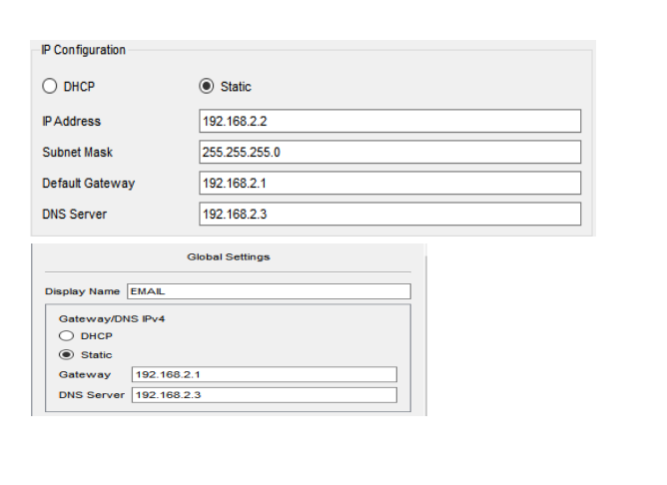

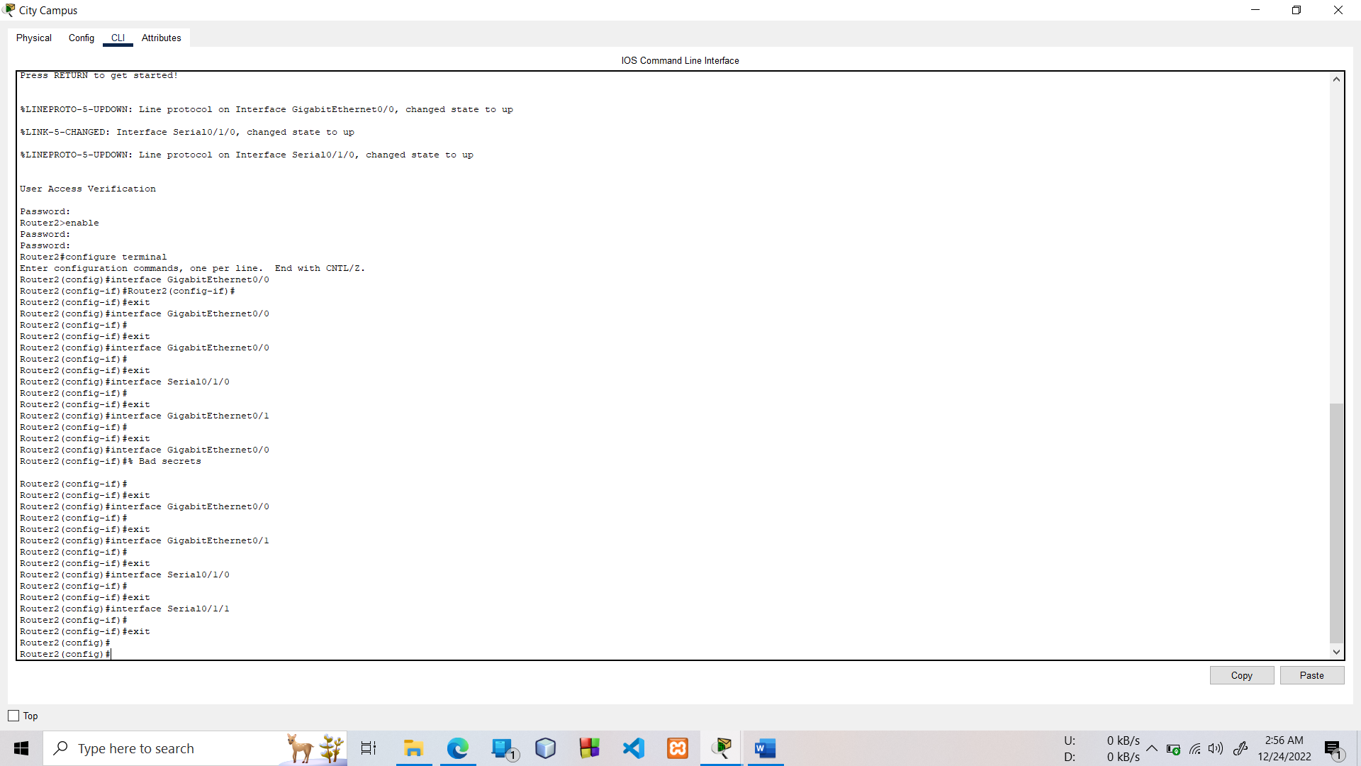

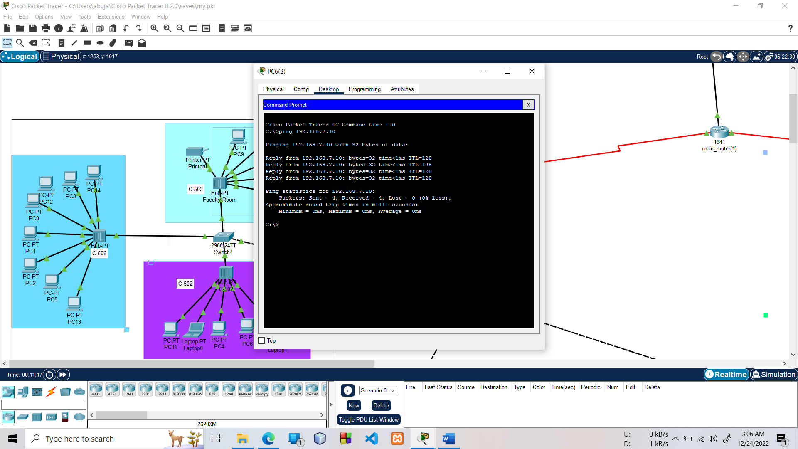

## Results and Discussions

Finally, I have combined all the steps as mentioned in chapter 3(3.2) and implemented the desired wireless network for university. We have the complete network providing various facilities to the teaching staff, non-teaching staff, and students.

* + 1. **Results**

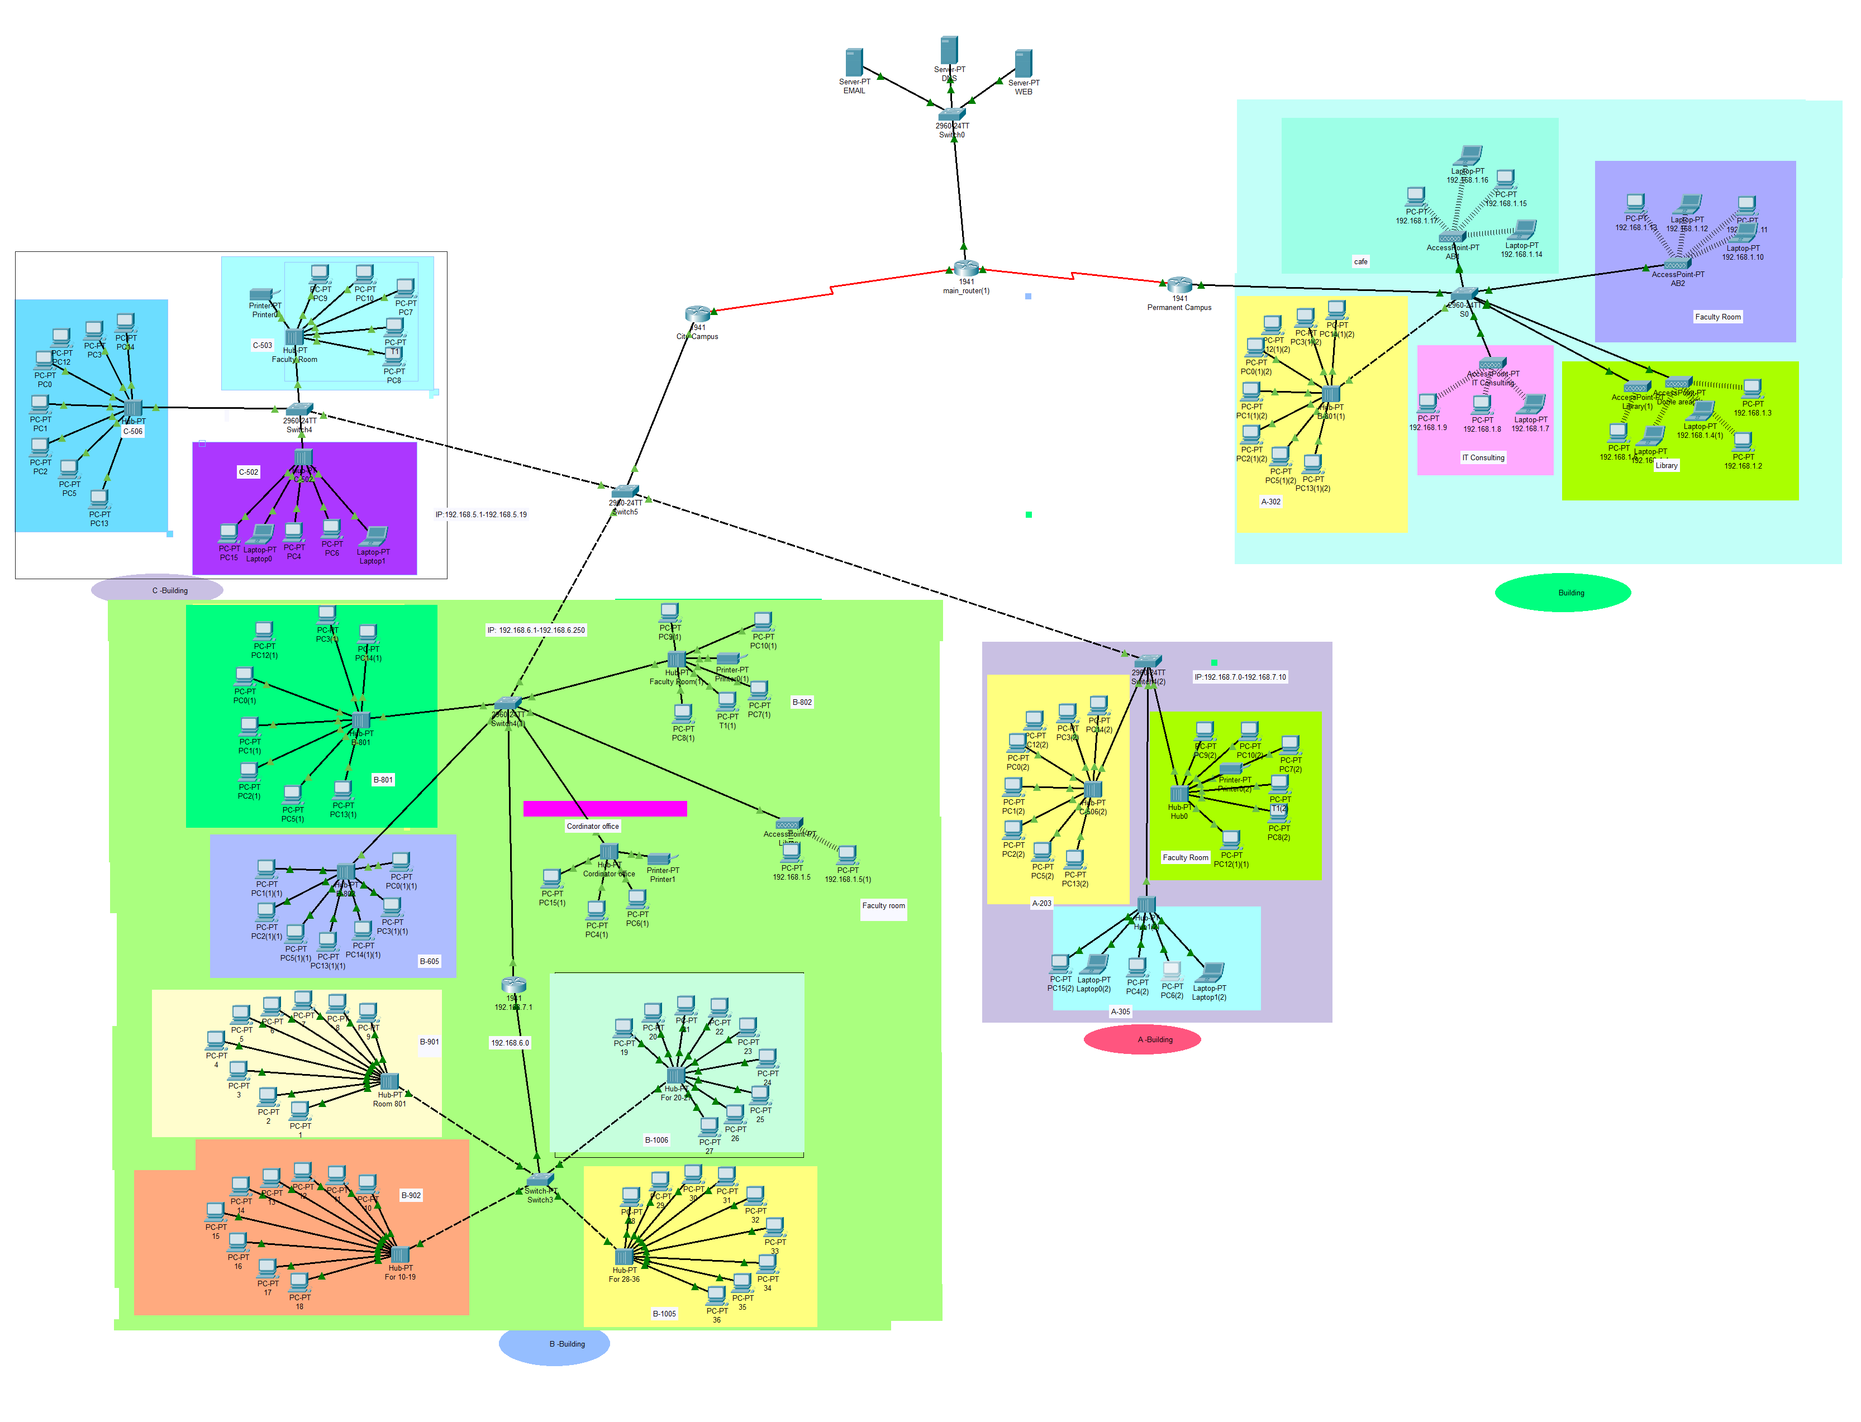

**Full view**

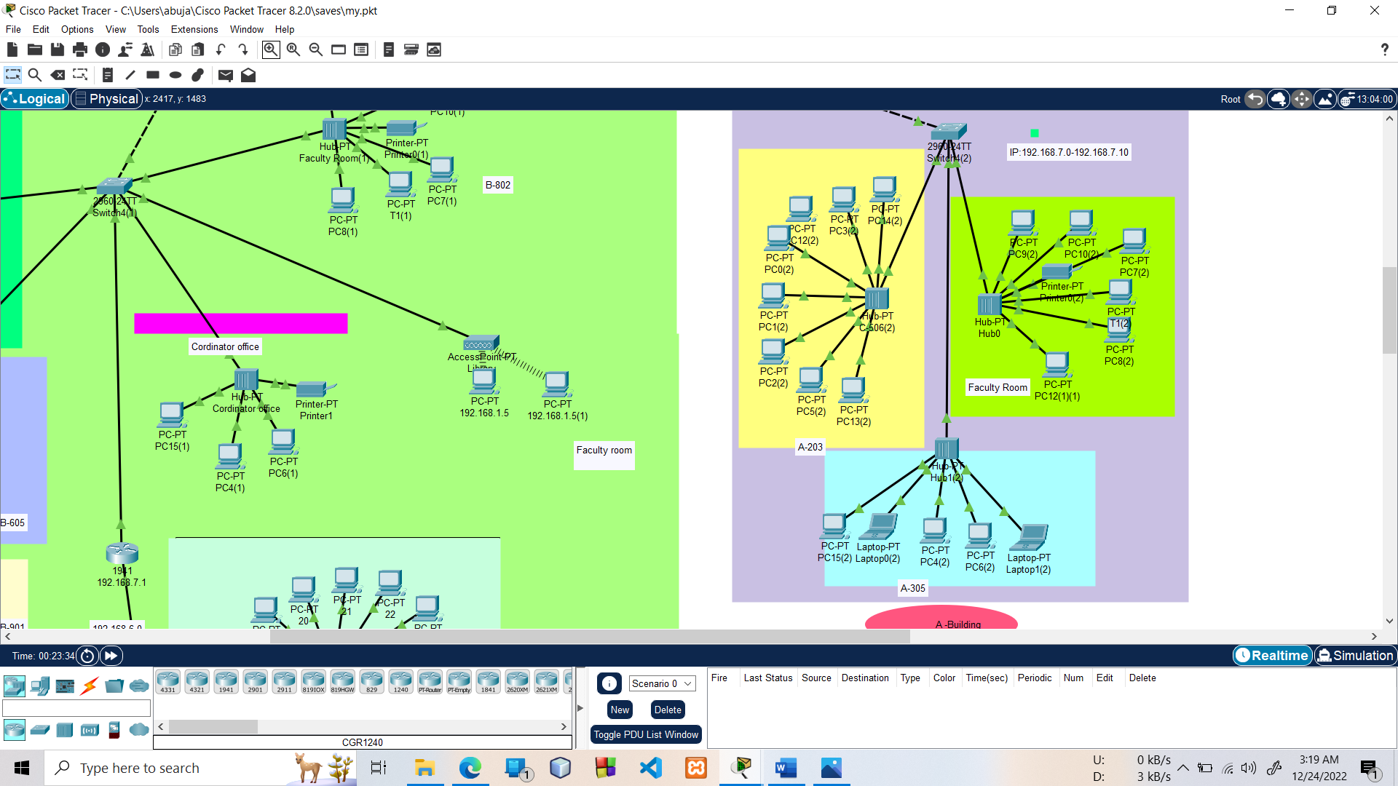

**A-** **building**

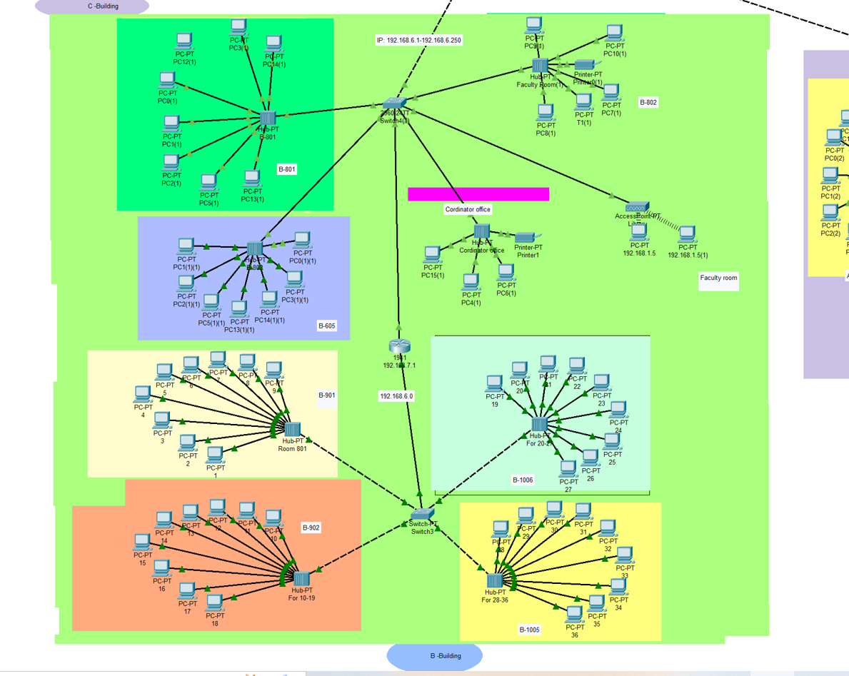

**B-** **building**

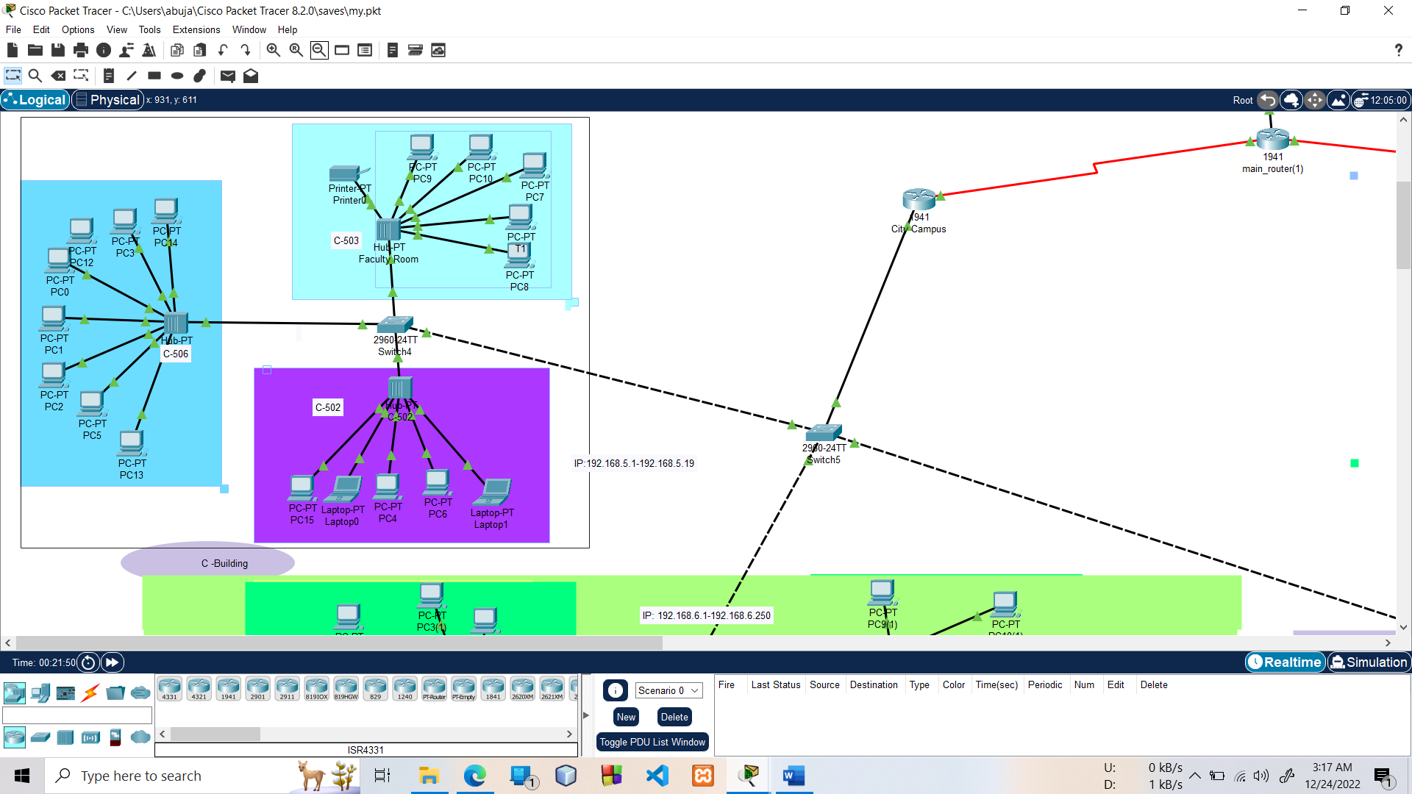

**C-** **building**

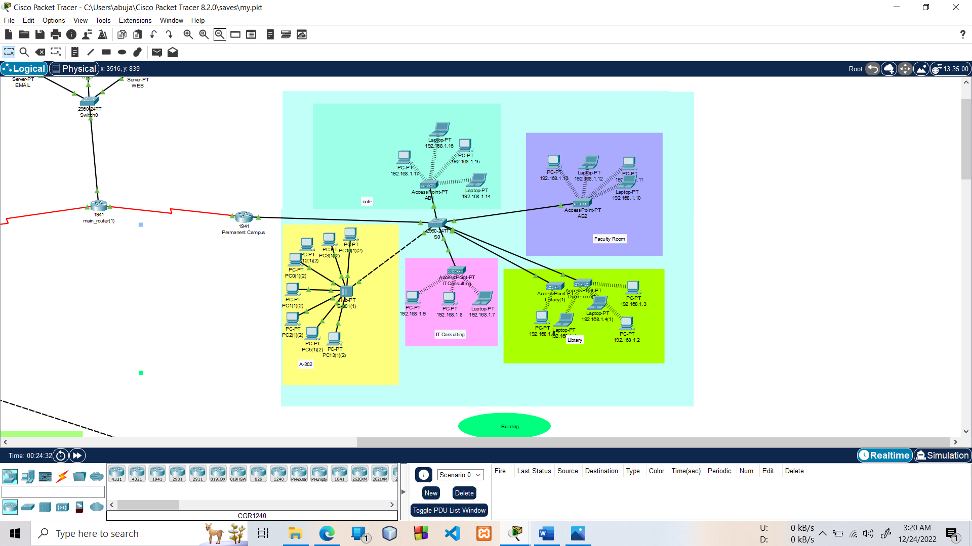

**Permanent -** **building**

* + 1. **Final Simulation**

In Simulation Mode, you can watch your network run at a slower pace, observing the paths that packets take and inspecting them in detail. The proposed architecture, when simulated on Cisco Packet Tracer, produced results which are demonstrated as follows:

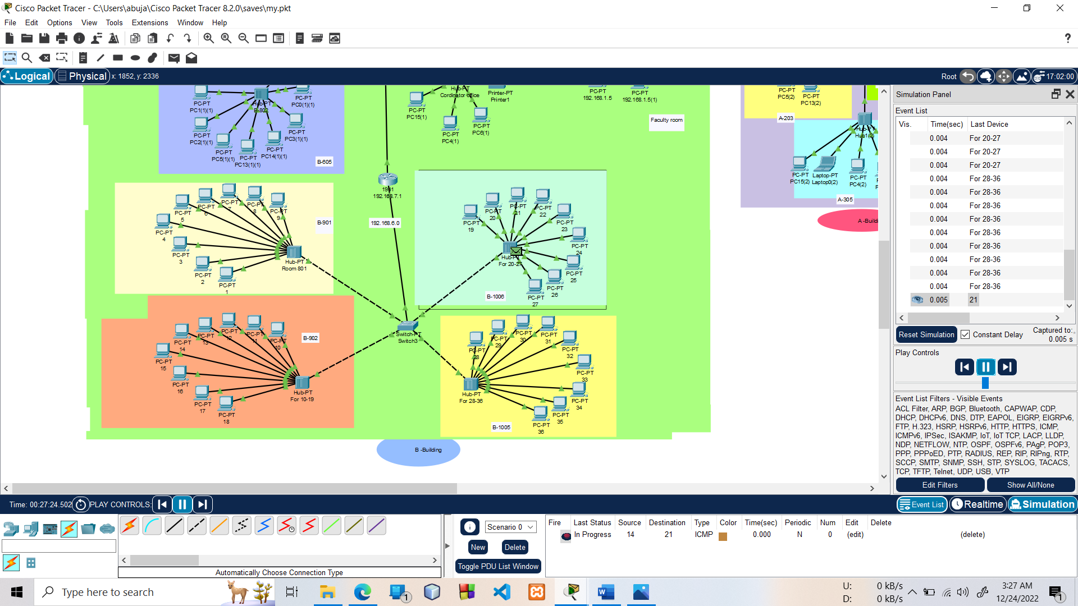

Final simulation for the network system to check all the connections

**Ping Test:** Network connectivity and communication can be tested sing the ping command, followed by the domain name or the IP address of the device (equipment) whose connectivity one wishes to verify.

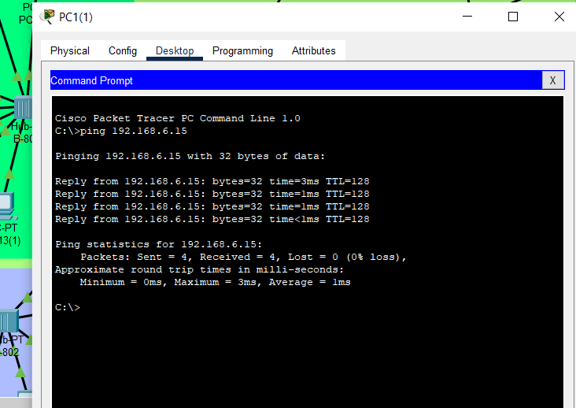

# 

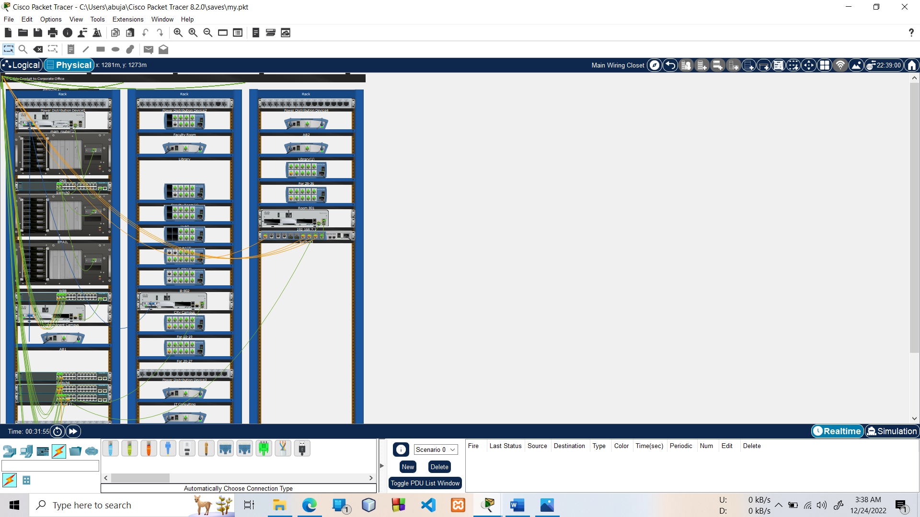

# Chapter 4 Conclusion

## Introduction

In this project, we will design a University Network using Cisco Pac ket Tracer that uses a networking topology implemented using servers, routers, s witches, and end devices in a multiple area networks. We will include a DNS server and a web server for establishing a smooth communication system between different areas of our network and specifically for the communication between students and teachers.

We will also include an email server to facilitate intra university communication through emails within the domain. We will also use console pass words and SSH protocol to ensure a safe and secure transfer of data.

## Scope of Future Work

The configuration and specifications are for the initial prototype and can further be developed

and additional functionality can be added to increase support and coverage of our existing

network.

# References

[1] https://en.wikipedia.org/wiki/Packet_Tracer

[2] https://www.paessler.com/it-explained/server [3]https://computernetworking747640215.wordpress.com/2018/07/05/secure-shellssh-configuration-on-a-switch-and-router- in-packet-tracer/

[4]http://router.over-blog.com/article- how-to-configure-cisco-routerpassword-106850439.html

[5] https://www.cognoscape.com/benefits- going-wireless/